Blind man's keyboard. A view on our habits and tools, a case for the dvorak writer

Benjamin Juarez - UNC / CIFFyH

benjij_1980@yahoo.com

Córdoba, Argentina

Abstract

Where did the qwerty keyboard layout come from? How did we come to use it nowadays? This paper intends to give a review of what came before of this convention that works until today. My argument here states that understanding why we came to use a conventional keyboard layout reveals both the manner in which we adopt standards as a regular and necessary basis for everyday-life and at the same time shows how a standard can also be biased and not thought of. This applies to objects, habits, frames of (social) thought, (social and non-social) analysis, etc. On a wider scope, the use of communications involves that it's important we become aware of how much we write, and hence communicate, and open up to an always renewed sensitivity at the personal (physical) and social levels. The paper goes through scribes in middle ages, through the press and getting to modern typewriters and their design. Keyboard layouts are reviewed. Then, convention is placed as a sociological phenomenon to be polished in its implications. In the end new layouts are offered and a theoritical background to support the possibility for new stand(-moveable)points.

Keywords: keyboard layout – convention – standards - communication

Now, what is this?

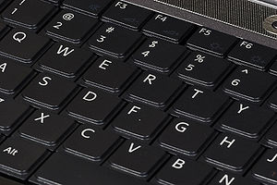

This is a picture of a fragment of a computer keyboard. I've put it here because I'm curious of how it's designed and it's an object that we use everyday. In fact it's not the design that is the key feature of my interest but rather the “naturality” of our assumptions to just take everyday-objects as they are. In society we are all mixed up together with more than our sole bodies, we rely and depend on objects to an extent that becomes more and more suprising day by day. Here a piece of literature, to illustrate my point, showing this type of connection:

Think of this: when they present you with a watch, they are gifting you with a tiny flowering hell, a wreath of roses, a dungeon of air. They aren't simply wishing the watch on you, and many more, and we hope it will last you, it's a good grand, Swiss, seventeen rubies; they aren't just giving you this minute stonecutter which will bind you by the wrist and walk along with you. They are giving you - they don't know it, it's terrible that they don't know it - they are gifting you with a new fragile and precarious piece of yourself, something that's yours but not a part of your body, that you have to strap to your body like your belt, like a tiny, furious bit of something hanging onto your wrist. They gift you with the job of having to wind it every day, an obligation to wind it, so that it goes on being a watch, they gift you with the obsession of looking into jewelry-shop windows to check the exact time, check the radio announcer, check the telephone service. They give you the gift of fear, someone will steal it from you, it'll fall on the street and get broken. They give you the gift of your trademark and the assurance that it's a trademark better than others, they gift you with the impulse to compare your watch with other watches. They aren't giving you a watch, you are the gift, they are giving you yourself for the watch's birthday (Cortázar –my highlight–).

In the same way that one becomes “attached” to a watch, a living person-object a life together, a similar fashion happens with the blind man and his stick. A blind man's stick is important for whoever uses one and the user is certainly aware of the stick's importance and how they use it.

The main underlying idea for this paper is that social conventions are social facts, that is, both cryztalizations (in a very material sense, because of its efects) and social constructs (that are constantly reconstructed in different fashions by individuals working together in society). Conventions are then ways in which customs become naturalized as common sense, and in this interplay between customs and people, objects play a part as well.

Emile Durkheim considers that not only people, but artifacts too (that is, objects used by people with human purposes) are to be considered as social facts. As he says in The Suicide (1897): “it is not true that society is made up only of individuals; it also includes material things, which play an essential role in human life. The social fact is sometimes so far materialized as to become an element of the external world ... Social life which is thus crystallized, as it were, and fixed on material supports, is by just so much externalized, and acts upon us from without (In Olsen: 6)”

As we take some customs and conventions as second nature, so does the blind man who uses a stick “naturally” and (despite all usefulness) does not properly feel the stick at all times but rather feels whatever is beyond the stick. Hence, the blind man's stick works as an extension of the own body. This involves both a way of using, that's is executing movements with the stick, and also a way of percieving whatever is beyond thanks to a body map that includes the stick. Acording to Merleau-Ponty (169) these two features are the first the motor habits and the second, the perceptual habit. This second one is that of my interest.

In fact my concern starts with the object keyboard and it's design in mind but the underlying factor to be researched is how we relate to this device and the way in which we use it. In the end it becomes to us, as users, a tool that works as an extension of our own self and to a certain extent, as second nature. And that is a point that deserves, from my perspective, of renewed attention.

But we are not merely “users” of technology. Nowadays the word “prosumer” engages the idea that we use and at the same time produce with our daily activities. So it would be important to undestand how we relate to the media we use from different angles. I've chosen keyboard design as a starter but it would also be illustrative to check how big publics appeared progresively with a different relationship with written material and the way they got to mass production.

But after a period of adoption of standards, why do we act massively with those media? Why do we take books or keyboards as the standard material? This is changing today, we do realize that we read signs all around a city and write in plenty of formats, digital and analogical.

But when we come to keyboard use: Why do we follow traditions with no questions asked? This is ok and necessary for everyday life where the need to take some things for granted is prevalent. But the question remains: to what extent do we act by the dictate of tradition?

The puzzle in the subject of design and habits is understand how we come to “engage” in certain things in a certain manner. And we do so not only as writers (consumers of the market product keyboard) but also as readers of culture and how we mesh and understand our surroundings.

It's not solely a matter of how people can act-do-think-talk-write but also it is possible to create habits of how to recieve (x)-host-perceive(outwards and inwards)-listen- “read-the-world”. That is why it is important here to understand the whole construct of a system of letters-words-communication on both sides, how we write but how we changed the customs on reading and approaching all literature (not only read material but the whole of culture) in a material sense. Not only rationaly but also perceptualy.

It's common sense that life today wouldn't be the same if there were no fire, wheels, or for the case, computers. But why? For the case, what is it about computers if they were different? I'd like to review on the logic that underlies keyboard's convention as it began and how it came to remain as a tradition passed on (year after year). How and why does it remain? It's also common sense that we use all kind of (social) objects every day but we don't very much live with a constant awareness of how we use them and how they became to be.

It would be possible to trace back a history of how men have done inscriptions, and to a certain extent I consider this a very interesting idea. However another author Tim Ingold has already gone through that path with a book called just simply Lines. A brief history. Next, just a broad overview from the point that is demanding attention: how people have becomed writers in the past, to afterwards how we become so nowadays.

The prehistory of mechanic writing: scribes

Back in the (so called) dark ages of medieval times the way books got copied was by hand. The curious thing about the way that books were copied is that in many cases the letters were copied one by one without having any meaning for the person in charge of the transcription. In this sense it was more of a manner of copying pictures or just recognizable letters but in no way was a process of rewriting an understood piece of text.

There was a specific group, the scribes, that took care of this activity and it was assumed to be a very demanding task considered from a physical point of view: it was a challenge of endurance, 'the whole body labours' (Clanchy in Ingold: 144). Here we show Lawrence of Durham in action:

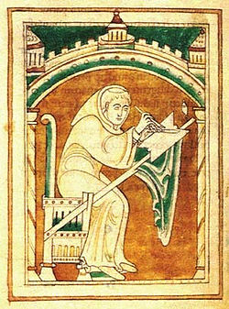

In the previous picture one can notice that while the scribe is writing with the pen held in his right hand (by the way: how and when may have this right dominance start?), he is holding back the springy surface of the parchment with a knife held in his left. This is why Ingold, whose “Lines” is the main reference for this section, points out that writing is not only a manual operation but in fact a bimanual one (144).

Compared to the hard work done in those far away times, Ingold states that today we have a certain illusion of disembodiment: when we use a pen our only arm movement consists of adjustments of the hand's resting position -my highlight- (review later on this point), while the remainder of the body is relatively passive and immobile.

In this section, in fact, I intend to stress that “writing” was a full body activity and that now we think of it differently. Or rather we don't think much of writing and in general of embodied activities, or even better, if we do think of them at all we only do so from a rational point of view, which in this case appears to point out solely on design, and not on percecptual process.

The underlying purpose to check on design is also to review not only the context of the practice (that is why Ingold's “Lines” is support here) but how the body abilities are acquired in certain conditions and affect our kinesthetic potential in a perceptive manner (Ingold, 1995: 191; Merleau-Ponty).

But again with history, going back to the pre-print times, it is to be remebered that the process of writing books by hand took a big deal of time, years, and had a high cost for market purchase.

How words started to get printed: the press

It is of popular knowledge (at least until now it is atributed) that the inventor of modern printing was Johannes Gutenberg. Beginning his life work as a blacksmith, it's said that he invented movable types made with metal.

There has been other prints in the world: time before in the east and with other techniques in the west (such as using woodblock printing), but what made Gutenberg well known was a series of factors that allowed his invention to spread through Europe with massive impacts in all society after his time. For one key feature was that Gutenberg was the first to create his type pieces from an alloy of lead, tin and antimony—the same components still used today. In this section, and the following three (before the theory section), my reference is Encyclopædia Britannica.

Gutenberg remains a towering figure in the popular image. In 1999, the A&E Network ranked Gutenberg No. 1 on their "Biographies of the Millennium" countdown. In 1997, Time–Life magazine picked Gutenberg's invention as the most important of the second millennium.

It is interesting how far went the wide spread in several directions of this huge cultural device. In the press's beginning, it's said that with the Church, thanks to press, indulgences were printed in high stacks. But on the other hand, printing was also a factor in the Reformation as Luther put a strong and largely heard voice to his position against indulgences. Further on, in a same modern and contestary tone, the broadsheet contributed to development of the newspaper.

But the book for which Gutenberg is best well known is for his 42 line Bible. It was a highlight of superb quality and a more accesible price than those made by hand: the Bible sold for 30 florins each, which was roughly three years' wages for an average clerk. Here, an original Gutenberg Bible, at Library of Congress, Washington, D.C.:

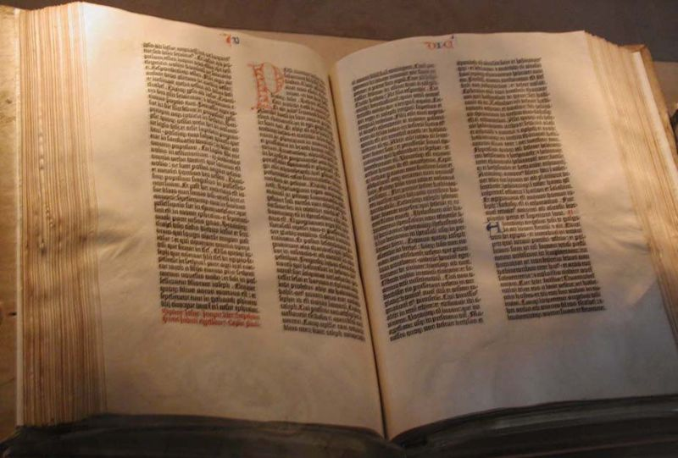

Nonetheless, this printed book was significantly cheaper than a handwritten Bible that could take a single scribe over a year to prepare. After printing the text portions, each of Gutenberg´s book was hand illustrated in the same elegant way as manuscript Bibles from the same period written by scribes, with capital letters and drawings.

The pages of the books were not bound, and the date 1455 is documented on the spine by the binder for a copy bound in Paris. The text lacks modern features such as pagination, indentations, and paragraph breaks. Just pages after pages of equal (but high quality) design... As the theorist Marshal McLuhan qualified centuries later, and placing his written words with design to confer meaning: what purpose did the press serve?...

“Printing, a ditto device

Printing, a ditto device

Printing, a ditto device

Printing, a ditto device

Printing, a ditto device

Printing, a ditto device

Printing, a ditto device

Printing, a ditto device

Printing, a ditto device

Printing, a ditto device

Printing, a ditto device

Printing, a ditto device

Printing, a ditto device

Printing, a ditto device

Printing, a ditto device

Printing, a ditto device

Printing, a ditto device

Printing, a ditto device

Printing, a ditto device

Printing, a ditto device

Printing, a ditto device

Printing, a ditto device

Printing, a ditto device

Printing, a ditto device

Printing, a ditto device

Printing, a ditto device

Printing, a ditto device

Printing, a ditto device

Printing, a ditto device

Printing, a ditto device

Printing, a ditto device

Printing, a ditto device

Printing, a ditto device

Printing, a ditto device

Printing, a ditto device

Printing, a ditto device

Printing, a ditto device

Printing, a ditto device

Printing, a ditto device ... provided the first uniformly repeatable 'commodity', the first assembly line-mass production” (according to McLuhan: 49-50). And these conditions are still today part of the environment in which readers-writers learn, that is why it's important to stress the influence that the press has in the double learning of reading-writing and all habits near them, against repetition, tradition, unconsciousness, etc, etc, etc.

How we got here: some typewriters before Sholes

As noticed in the previous paragraphs, press allowed books to be made in a faster and cheaper fashion than what was done in medieval times. As mechanics got improved in machines along time, several ideas appeared in different places to improve the press and how to add new features.

The motives of each improvement, or invention, were diverse: to gain a mechanical method to print the number of pages in books, also as help for the blind to have an actual way of writing and just simply to write letters in a manner that could be indistinguishable from that of the print.

The first typewriter patent was filed in 1714 by the British engineer Henry Mill, but there's no evidence that an actual machine was built. By 1808 the italian Pellegrino Turri constructed one typewriter but no further socialization of such a construct was intended.

The first comercially produced typewriter was the Hansen Writing Ball, invented in 1865 and patented and produced from 1870 and following. The typewriter was not a keyboard but made as writing ball:

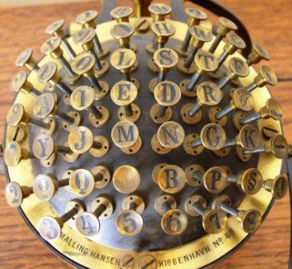

The Hansen Writing Ball was called the skrivekugle in Danish. The Hansen ball was a combination of unusual design and ergonomic innovations, but like most of the early 19th century typewriters, it did not allow the paper to be seen as it passed through the device.

The new machine had a very valuable feature for the epoch: it was a model that was lightweight and easy to carry. It was Friedrich Nietzsche who saw this apparatus as useful. Since he was having serious problems with his sight he decided in 1881 to buy one of these new skrivekugle, and in fact he chose this one over the upcoming american Remington's Nº 2 since he found this european device to be more of the portable kind.

Unfortunately Nietzsche wasn't totally satisfied with his purchase and never really mastered the use of the instrument. As one researcher has noted, "Nietzsche's interest in rhetoric and his experience of the typewriter framed his understanding of language in a highly symbolic way: the traditions of the philosophy of language versus the scientific and technological conditions of knowledge." (Emden: 28)

On February 16, 1882 he even made a poem about his writing ball (my highlight):

The Writing Ball is a thing like me: of iron

Yet twisted easily – especially on journeys.

Patience and tact must be had in abundance

As well as fine [little] fingers to use us.

As is to be seen later on, the matter of developing a tact in regard to things, as well as to people, is not only a big deal for this author but it will be a key feature in the argument placed here.

Sholes 1st keyboard layouts. About qwerty

The 1st machine to be most credited as of mass production was the Remington & Sons's model of 1874, based on a prototype by the american inventor Christopher Latham Sholes. There is much to say at this point since this basic model would to be the main frame for keyboards as most people use today: it used a keyboard today called the qwerty keyboard layout.

The qwerty keyboard's name stands for the arrangement of keys from the upper left sequence of letters as in the 1st picture of this writing. It´s the standard keyboard layout today and is also called the Universal Keyboard. It starts with Q, follows with W, and so on to form the whole name: qwerty. Pc computers today have the same structure of that keyboard layout that goes back to at least 1874, and most likely further. How wsa it born? Nobody is quite sure (see Yasuoka & Yasuoka). But why and how does/did it persist? More than 135 years later this design continues.

The first Remington model had plenty of flaws and was not very well selled at first. The major backdown was that the paper that came type-printed out from the machine was looking away from the writers view. In this way, until a person took the paper out he/she wouldn't notice if they have succeded or not in their writing. A repeating key jam could leave just a whole page of one same letter: it was the invisible jamming. Besides, this first typewriter worked solely with upper cases, which in some cases was considered impersonal. Also, it had no key for the number “1”, it was assumed at design level that it could be replaced for a letter “I”.

But in reality, to say that we still use this first design patent is not fair in at least two senses. In first place that the way in which Sholes started to think of the design for a keyboard was actually using a piano as a model (he really may have thought of this and other ideas at the same time as others), and that is one of the many ways in which we find it patented in a piano-like destribution:

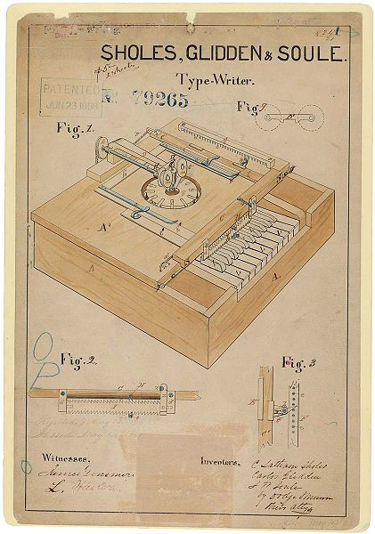

And in fact this first idea had no letter pattern to follow so it just went with an alphabetical order, Sholes began his experiments in 1867, many years before the 1st Remington. And indeed from that old idea of alphabetical order still remains with vestiges until now the arrangement of keys in qwerty's homerow (that is, the middle row, in between of the upper and the lower ones) that is nearly in alphabetical sequence and goes DFGHJKL.

As a second point, the title of this section says “The 1st Sholes keyboard layout”, it refers in fact to this Remington 1st model since it was recognised as the massive product that impacts until today. But it should be known that Sholes and others experimented with other keyboard settings. Qwerty was intended to be used only as a prototype and not as a finding to be patented as a copmletely finished design.

In fact, it remains a popular idea that it was Sholes who designed the qwerty sequence of letters but according to Yasuoka & Yasuoka there is a misunderstanding about the origins of qwerty that is widely spread. But the true origins of the qwerty layout have not been yet elucidated.

In any case, the theoretical view on this section intends to point out that many technical aspects of the machine-keyboard were put into consideration to build this industrial artefact, but regards of human-functional topics did not rule in that discussion. The bottom line is that the history of how this convention was born is rather blurry and we seek for clarity in how social factors came into play for the apperance and maintenance of designs.

The problematic subject
1 Keyboard (layout) as convention (of use)

Up to here what has been presented was the ubiquitousness of the qwerty frame. Indeed this in itself could be considered as a sociological phenomenon. How can certain objects and conducts (and not others) become so standarized as to dictate a one and only conventional way of use? Why do people attend to certain (and -again- not other) maps, mental images or habits? The topic of social habits and standarization of every day thoughts is not actually about keyboards alone but one that goes through the whole of social and philosophical thinking.

That life has continuities, as well as a big deal of change and incoherence in itself, shouldn't come as a surprise. In the mesh of human activities it's only expectable that objects of all shapes and colors should play a part to make the social construct function. In the common view of social sciences, however, it's a widely spread idea that society can live regardless of any physical support. Attention in this point, is however maintained by some. Previously was mentioned how Durkheim considered things as social facts, that become meaningful and a permanent element of society in the same way that customs form laws and these interfere in social life.

Bruno Latour in Reassembling the Social stands for the weight of things to put society together:
“As soon as you believe social agregates can hold their own being propped up by “social forces”, then objects vanish from the view and the magical and tautological force of society is enough to hold everything with, literally, no thing (In Olsen: 129).”

One can agree with the notion of things as part of society but a key question that follows is: what part do things -in fact- play? And how do they “come to life (that is, social life)”? Social objects come to work as people use them, in some degree it could be said that “things are just people acting together”. And moreover, one can consider objects as “the embodied residue of people's activities” as stated by Howard Becker (46, 44).

However simple it may seem stated previously; any gesture, as personal and unique they can feel, mostly have inscribed some way of “social tattoo” on it. Among tasks to follow, Elias said, there is to distinguish in each case what corresponds to social factors and which to personal features.

And in the end our main question keeps us asking: what are the traditions that are imposed? As Mauss had pointed out, it's not enough to know about physiology or psychology, but we need to investigate as well on the social practices that give path to incorporated activities. In this way we can learn about how certain habits that we take as natural are actually historically embeded.

The part that social objects can have in society has been here quickly reviewed, it has not been intended to be an exhaustive approach but an introduction to understand the place not only of objects but also of human habits for social stability, and mobility of the individual´s patterns of action.

2 Convention reaffirmed, but among which other alternatives?

None the less, we are to remember that not all in society is cohesion. Or, better said, not all social cohesion works in all situations at it's best... From an optimist standpoint, Steven Johnson says that environments that provide sharing patterns can nurture new capabilities of thinking. He has in mind a metaphore that doesn't follow the idea of inventions coming from flashes, epiphanies or eureka moments. But instead he sees that people coming from different backgrounds can produce such a mixture that favours a liquid network where ideas connect and are likely to create social (not only individual) breakthroughs.

This stand point is of the positive kind: different people talking together, in an easy fashion and from diverse backgrounds, do tend to promote socialization and creativity. But within this logic one could notice that not all social groups react in the same way to unconventional pushes. There are only certain moments, places and circumstances in which such ideas flourish.

It is expected that whatever lives does not remain dull, or for the case...dead (at this point, Latour's comment on developing our senses is very pertinent). Norbert Elias (1991: 63-64) reminds us that in society, canons and social methods don't appear systematically, they “develop in the long term, blindly and without premeditation”, and “inequalities and contradictions are part of the recurrent structural properties of the process of civilization”.

Social agreements embody in patterns and also in physical objects. And they even do so in objects that don't seem to have much rationality behind them. In the case set here there are historical reasons for the birth of qwerty but the object here treated works as an example of a non-functional convention. Becker places his position against one specific convention, to which we are directed now:

A classical example is the QWERTY keyboard, an inefficient and dysfunctional arrangement of typewriter keys that highlights the enormous influence of early steps in the creation of standard objects. Once the keyboard had been arranged that way ... it proved totally resistant to the introduction of better arrangements (like the Dvorak keyboard, whose users are faster and more accurate). Too many people already knew the old way to make changing “practical” (Becker: 50-51).

In fact saying that the object in trial is faster or more accurate than other is a point in which we are not interested here. There has been many debate among specialists that compare several layout designs among each other according to different objectives.

Some other developments by Sholes and others

To be true to Sholes it should be said that the qwerty arrangement came only as a way to avoid letters jamming. The details of this issue are not to be mentioned now (it's a matter with excesive details and controversy). But the fairest thing to say about Sholes is that after designing the piano model, afterwards using qwerty solely as a prototype, he later invented a more logical way of placing the keys.

He considered that all vowels on one same side and in the home row would allow fingers to rest in that position and to be used in alternancy between left and right hand. In the picture we can see the right side of the home row stands with the sequence aeiouy.

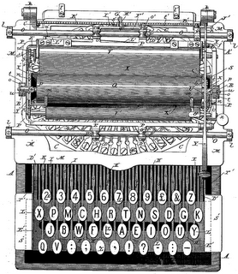

But sadly the Sholes V. 2.0 was not given to any consideration. To a certain extent the supporters of “the old order” of qwerty were the manucturer Remington and other investors that rejected Sholes new design. But it was also a rejection from the public and trained typists that were beginning to get familiar with the keyboard as it was, that is, qwerty.

After some years many competing keyboards appeared. For instance, the Hammond and Blickensderfer Ideal keyboard used only three rows and sensibly put the most common letters in the bottom row for easy access, in the sequence DHIATENSOR.

A very well functioning machine appeared as competition to the monopoly of Remington in 1893. The Underwood's Model Nº 5 typewriter gave two important benefits: visible typing on the front side of the paper, and a component called an accelerating sublever that permitted faster speed. However, it used a qwerty layout.

With these last improvements in design and sales by Underwood, in 1894 Remington came out with it's Model Nº 2 which introduced a shift key (that allowed upper and lower cases) and it also included the number “1” key. With previous models Remington hadn't gone very well: between 1873 and 1878 only 5000 machines mere sold.

By 1900, 12 years later, with this new design (Model #2 -1894-) Remington was selling 100,000 typewriters a year. Qwerty...remained.

The competitor. The dvorak case

(As a personal note, if I would have chance to defend the dvorak layout it would be by reason of comfort at hand). In the following text it will be intended to see what are the purposes underlying the dvorak design.

To review the actual keymaps is to put in doubt what is normally taken-for-granted. The reason why people do use qwerty is because of custom. And that's ok. But are there other options? To say not, is to follow the logic of refusal to new options, which leads to follow on with the old ways just because. If dvorak could be a stand it may come as an important interest that it can help reduce repetitive strain injuries including carpal tunnel syndrome.

Studies that are not biased are hard to find or rely on. The proposal here is to put at hand a possibility to feel something in a different way and to offer the reader to a self-constructed path of trial and error to review on.

Dr. August Dvorak (1894-1975) and his work is the focus for this section. A distant relative of the famous czech composer Antonin Dvorak, Dr. August Dvorak was an educational psychologist and professor of education at the University of Washington, in Seattle.

Circa 1914, Dvorak's brother-in-law, William Dealey went to industrial efficiency seminars and saw typists at work in slow motion (with early filming for industrial purposes). With this in mind almost two decades were devoted to enormously detailed studies of typing, typists’ errors, previously designed keyboards, hand physiology and function, and the relative frequencies of letters, pairs of letters, and words in English. Finally, in 1932, they took what they had learned from such background. They designed a new keyboard:

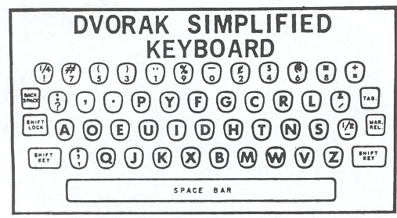

Not only did Dr. August Dvorak research letters, diagraphs and words, but he also examined actual typists and their practices. As said before, there are plenty of controversies regarding if the benefits of this keyboard are worth a shift from the standard. For now, just some of the main reasons by which dvorak is built (Longstreth; Cardiff & Carleton-Barnes: 7-8):

If you are typing qwerty only 31% of your key strokes are on the home row. With dvorak though, 70% of your key strokes are on the home row. Also Dvorak placed all of the most commonly typed consonants on the home row, as well as all the vowels. By keeping so many keystrokes on home row, dvorak reduces finger movement between rows by a factor of three. That reduction in finger movement means more comfortable and ergonomic typing (L; C & GBC: 9-10). Here, a visual comparative:

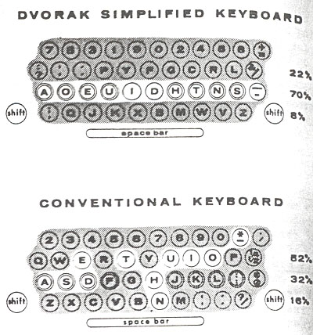

Also the new design considered the differential strength of each finger and requiring a distributed range of effort for the dvorak simplified keyboard (DSK):

If stroking is arranged to move from the edges of the board to the middle, an observation of this principle is that -for many people- when tapping fingers on a table, it is easier to go from the little fingers to the index than vice versa. This motion on a keyboard is called inboard stroke flow.

More efficency is also attained when letters are typed by alternating between hands: which makes typing more rhythmic, increases speed, reduces error, and reduces fatigue. A suggestion to try this point is as follows: take one finger and tap it on a table as fast as you can. Now take one finger from each hand and tap them alternately (from L; C & GBC: 11). In this fashion, with the DSK vocals and consonants on each side practically guarantee at least one alternation per word.

Other features could include: The right hand could do most of the typing (since most people are right-handed), the least common letters could be on the bottom row (which is the hardest row to reach), digraphs could not be typed with adjacent fingers.

Sadly for Dr. Dvorak he saw no happy outcome to his life work. But, on the bright side, years later after he was gone his job got proper recognition. In 1982 the dvorak simplified keyboard (DSK) layout was officially recognised by the American National Standards Institute (ANSI). This means that since then each computer has a sleeping dvorak preinstalled (as available software) and is waiting to come out as an alternative.

But in the end, who cares about all this? Even hardware isn't likely to be used in the future (see Mistry). But frames of action are the interest here. It is not suggested here that a one design should be imposed as mandatory. The dvorak option has not necessarily to be for everyone but it promises a better future for the physically impaired, for the curious, for those who enjoy an aquired lazyness, and for children to learn a system that has reasons to make typing an easier way.

Some might see a dvorak keyboard and state that “that is not a keyboard”. These are the kind of statements that support the interests of those we are happy with things as they are and could feel threatened with a change. Saying what something is or is not, following Becker (158) is a way of saying “how that thing ought to be acted toward or, if the name sticks, will be acted toward”. But there is actually not much reason to say something is or is not, rather it's possible that it may be many things. A keyboard can be standard but can also have infinite forms. And the same applies to how we build or use them.

A further opening of the (key)map

Dvorak is the option chose to be mentioned in this work but further and alternative developments have been made. A layout appeared not so many years ago was the Colemak, it intends to offer a new layout to shift from qwerty to: maintains the old position of the most used keys for shortcuts undo, cut, copy, paste, and close (ctrl + z, x, c, v, w). One intersting point that this keyboard offers is that it replaces the caps lock with an additional backspace key:

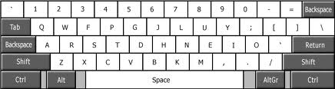

Other layouts to be mentioned could include the german version of qwerty that replaces the “y” for “z” (because this is -logically- a more frequent letter in that language), hence called also a kezboard. Also should be noticed that in China a variant of qwerty is used, so depending on how it actually works the problem set here may well be of a global type, not just for the west.

Back to the alternative standard considered here, dvorak was not only thought of as one sole design but was also considered for one handed writing, both for left hand and right hand. In this sense, this may fit better for nowadays technologies that can fit in a single palm, or even be modified to optimize the use of the thumb (instead of the other fingers). Here the graphic:

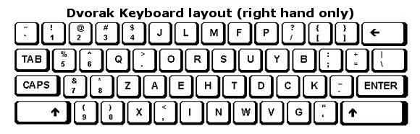

Last and with somewhat of a promise (with intended logic -regardless of how deeply-), is the FITALY. Designed specifically for use with mobile devices. The FITALY layout, which is optimised for use with a stylus to place the most commonly used letters closest to the centre and minimise the distance travelled when entering words.

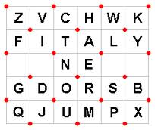

If new options have appeared in recent years that give more possiblities to write they could all work helpfuly to make changes easier. This comes as innovations and easy transitions that make it possible to move from allready standarized conventions. Chances are open. Here the finding is that not only habits can change but that the situation affects objects at the same time.

Wrapping up

“Feel better” is one motive mentioned above as a goal for how to use technology. Concluding already, it's fair to say that we reviewed pieces of hardware to understand how they where thought of and used in society. In this sense it has been made justice to a problem raised by Olsen (80). He had said that we know how to use a keyboard, “it is knowledge in the hands”. But the question was raised: Should credit also be granted to the properties and capacities of things? In some way the answer is yes...because... Objects are part of the taken for granted world and that means a conditioning for human life, that is why it is significant that we become aware of them and how they affect ourselves. Also that we produce them.

The result is mutual: objects condition social life but social life conditions social objects as well. The intention here is not to give an abstract theory or mere explanation of historical changes in tools or habits. At the beginning we placed the problem of the understanding of the physical world. And since the topic has been well forgotten as a discoursive that constitutes ourselves, investigating keyboard and conventions places the problem of how and why we use them in certain ways rather than others.

Underlying our study is the goal of giving credit to objects to learn from them because they can make the world a more complex one, where we can find new discoveries. And the discoveries searched here are not only about ideas but of something that is concrete. If the choice of study has been on a tool it is because it is not an abstraction, and hence it demands a specific kind of understanding. Percepetion is not a universal (or universable) treat, it is always situated.

But in the core remains the subject of how we end up using the objects ourselves and how that involves oneself in an immediate way. It is not a thought process, one to be elaborated with words, it is rather to relate to by action, with a non-discoursive consciousness (Marshall McLuhan, in McCloud: 38). One does not only feel identified with certain objects as extensions of oneself but also elaborates a form of non-visual awareness that puts us in place of the objects we handle. When we drive a car, the vehicle becomes an extension of our body. We become the car:

When we get involved with things we feel them ready-to-hand but at the same time they are not only tools but become an extension of our self and configure a mode of being. At this point it is noticeable that things relate to their role in motor habits and the way they extend the body (Olsen 78, 69-70).

In this sense, the exercise of reviewing our case on dvorak here intends to serve the purpose challenged by Malafouris to overcome the view that sees material culture as an epiphenomenal product of the human mind. Object themselves play a certain effect on people's self-awareness (Malafouris: 410, 406, 408). And yet, at the same time, it is again the social practice that re-constitutes the objects in play.

If previously it was mentioned that perception could be a key to learn from the physical world (in the sense that Latour learns how to “become a nose” to perceive more qualities of the world) also “tact” plays a part in socialization. This of course may sound common sense, but the challenge is that a finer tact as well as new metaphors can always be developed further to deal with and grasp reality. Work on this path has done before, as did Irving Goffman.

Goffman's book The Presentation of Self in Everyday-life intends to analyze the ways in which people communicate. But he distinguishes two kinds of communication: that which is intended to be expressed and that which is expressed as an (non-verbal) emanation of the person. The need to define rols in situation help people know who and how to interact. But in Goffman's work the important feature is to not take social places as already given and always the same but to figure them as multiple and interchangeable according to context. The social place is not something that just is (in one way only) but rather something that is made constantly as people come to act (Goffman: 14, 16, 86).

If this paper is to end on the body and objects coming together in mutual interplay, at least two things should come up front. First, that there is a place and time for autoreflection, for persons to learn how to feel themselves (not necessarily in an emotional way, but yes in a Kinaesthetic style) and the objects they use. Second, that this possible development opens a gate to another kind of sensibility, that is of the social world, this idea is already socialized in the expression “to have tact”. Learning both practices can be an endeavour with no end. So be it.

Closure, or rather (re)aperture. Again with McLucan (24);

there
is
absolutely
no
inevitability
as
long
as
there
is
a
willingness
to
contemplate
what
is
happening

References

Becker, Howard S. Tricks of the trade. How to think about your research while you're doing it. The University of Chicago Press, Chicago, 1998.
Cortázar, Julio. Preamble to the instructions on how to wind a watch. In Cronopios & Famas. At www.proz.com, English version by Paul Blackburn. Original spanish version, Historias de cronopios y de famas, 1962 in www.lainsignia.org
De Sousa Chauí, Marilena. Merleau-Ponty. La experiencia del pensamiento. Colihue, Buenos Aires, 1999.
Goffman, Erving. La presentación de la persona en la vida cotidiana (1959). Buenos Aires: Amorrortu, 1987.
Elias, Norbert. Mozart. Sociología de un genio. Ediciones Península, Barcelona, 1991.
Emden, Christian. Nietzsche on Language, Consciousness, and the Body, University of Illinois Press, 2005, p28.
Encyclopædia Britannica, 15th edition (1943-1973). The University of Chicago, et al, 1973.
Ingold, Tim. Lines. A brief history. Routledge, New York, 2008.
Ingold, Tim. Lines. (1995) ’People like us’: the concept of the Anatomically modern human. Cultural Dynamics 7(2):187-214
Johnson, Steven. Talk at ted.com: Where good ideas come from. TEDGlobal 2010, Filmed Jul 2010; Posted Sep 2010.
Latour, Bruno. How to Talk About the Body? the Normative Dimension of Science Studies. In: Body & Society, 2004. 10: 205.
Longstreth, Alec; Cardiff, Michael & Carleton-Barnes, Gabe. The Dvorak Zine, Dvorak Simplified Keyboard Layout. At dvzine.org/
Malafouris, Lambrous. Beads for a Plastic Mind: the ‘Blind Man’s Stick’ (BMS): Hypothesis and the Active Nature of Material Culture Cambridge Archaeological Journal 18:3:401–14, 2008.
Mauss, Marcel. Les Techniques du Corps. Journal de Psychologie 32(3‐4). 1934.
Merleau-Ponty, Maurice. Fenomenología de la percepción (1945). Planeta-Agostini, Barcelona, 1994
References McCloud, Scott. Understanding Comics. The Invisible Art. Harper Collins, New York. 1994.
McLuhan, Marshal. The Medium is the Massage. An Inventory of Effects (1967). Ginko Press, Corte Madera – California, 2001.
Mistry, Pranav. Talk at ted.com: The thrilling potential of SixthSense technology. TEDIndia 2009, Filmed Nov 2009; Posted Nov 2009.
Nietzsche, Friedrich. Friedrich Nietzsche and his typewriter - a Malling-Hansen Writing Ball. At malling-hansen.org/
Sholes, Christopher Latham. In Encyclopædia Britannica, Micropædia, vol IX.
Typewriter. In Encyclopædia Britannica, Macropædia, vol 18.
Typography. In Encyclopædia Britannica, Macropædia, vol 18.
Olsen, Bjørner. In Defense of Things: Archaeology and the Ontology of Objects. Altamira. 2010.
Yasuoka, Koichi and Yasuoka, Motoko. On the Prehistory of QWERTY. ZINBUN (2011), 42: 161-174. KURENAI: Kyoto University Research Information Repository. URL: http://hdl.handle.net/2433/139379
Zetter, Kim. TED: MIT Students Turn Internet Into a Sixth Human Sense — Video. At wired.com: February 5, 2009.

